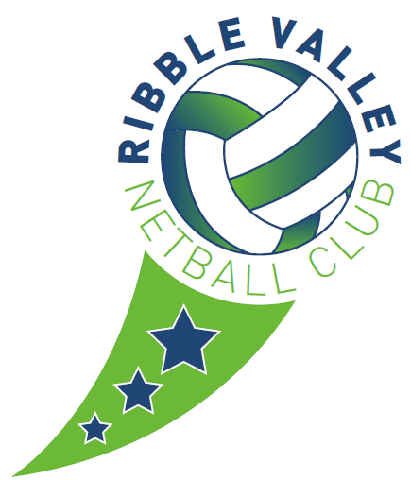
Club Safeguarding Officer
Role Description

The Club Safeguarding Officer (CSO) is the first point of contact for all safeguarding issues within their club. They are responsible for giving advice about the wellbeing, safeguarding and protection of young people, promoting good practice, ensuring the reporting a concern process is clearly communicated and understood within the club, and helping the club create a safe and enjoyable environment where everyone understands their safeguarding responsibilities.
The CSO is the person to take appropriate action on receipt of any concerns or referrals and liaise with EN’s Lead Child Protection Officer to handle concerns.
The Person
The Club Safeguarding Officer needs to be comfortable being well known in the club and in playing a lead role in advocating for the young people in their environment.
They need to be accessible and approachable, especially for young people.
Ideally the CSO will not be the coach or volunteer with direct responsibility for coordinating or delivering the junior programmes at the club, as it is important that this person’s role is as independent as possible.
Skills
Ability to handle a range of safeguarding and well-being issues in accordance with EN guidelines;
Ability to create an inclusive, safe and enjoyable environment in their club;
Respectful, unbiased, empathetic;
Approachable, calm, friendly and able to listen and give advice;
Organised and able to create and maintain records appropriately;
Trustworthy, tactful and aware of the need for confidentiality.
Preliminary Requirements
CSOs must:-:
Be affiliated to England Netball
Reorder their details on MyNet
Have a Enhanced DBS clearance check through England Netball
Training
Read England Netball’s Safeguarding Young People in Netball, Equality and Safeguarding Adults Policies.
Attend UK Coaching Safeguarding and Protecting Children workshop, or an equivalent recognised direct delivery course within 6 months of taking on the role.
Time To Listen Workshop within 6 months–1 year of appointment – please contact your Regional Coordinator for details of the next TTL course in your Region.
Main Areas of Responsibility
Policy and Procedures
Advising the club on the application of England Netball’s (EN) Safeguarding in Netball;
To provide information and advice on the wellbeing, safeguarding and protection of young people within the club and promote a child focused approach;
To ensure that all club members are made aware of and are clearly informed about the role of the Safeguarding Officer and know who to contact for advice, support, reporting and resources;
To promote awareness of the EN Codes of Conduct and to support the implementation of safe recruitment and induction procedures within the club;
To advise on the application of EN’s DBS Guidance and to be the point of contact for risk assessments and clearance communications.
Referrals
To be the first point of contact to receive information from anyone who has concerns relating to the welfare of children and young people and to record and report appropriately.
To clarify information received, ensuring that this is referred on promptly to EN’s Lead Child Protection Officer to enable assessment to be undertaken, and advice offered.
To follow the EN Responding and Reporting a Concern Procedure and flow chart.
Education and Training
To advise the club on appropriate training for coaches and volunteers based on the EN recommended safeguarding training requirements;
To signpost those with roles and responsibilities for young people to appropriate safeguarding training opportunities;
To educate the members of their club on the Reporting a Concern process and good practice in safeguarding.
Knowledge
Awareness of the local statutory child protection network, including the contact details for the local police and Children’s Services, the role of the Local Safeguarding Children’s Board (LSCB), Local Authority Designated Officer and an awareness of local inter-agency child protection procedures.
Understand the EN Safeguarding in Netball Policies and Procedures.
Basic knowledge of core legislation and government guidance on safeguarding
Have an understanding of poor practice and abuse – behaviour that is harmful to young people or has a potentially negative impact upon their welfare and enjoyment of netball.

For further information, contact the Compliance and Inclusion Team at England Netball Head Office
Tel: 01462 428319
Email: besafe@englandnetball.co.uk
Website: http://www.englandnetball.co.uk/make-the-game

